Name: Abel Bijumathew
ab2323@njit.edu

4(a) the challenges you faced in replicating the resultant data structure (the graph)

- It is always challenging to work with somebody else’s code. You have no idea what all issues the code in the repo has.
2) Setting up the environment was indeed the most challenging task. Almost one week, day and night of taking baby steps, especially I didn't have much knowledge on docker. So, I have to stick with getting the environment setup on colab. Taking the code piece by piece, bringing it to colab, testing it without knowing what the code is doing (initially) was a very challenging task – 16+ hours a day for almost 8 days.
3) Cross compatibility of libraries. When importing some libraries, it has some base requirements connected to other libraries that sometimes conflict with the functions or the functions written in the scripts.

4) Debugging script – No time to understand the scripts and all the dependencies – at times, I was confused about a particular specific piece of code. When running the script, most, if not all, of the scripts had errors. Some were because the package installed during the development time has changed now to the way it functions or takes arguments. Some scripts had to be adjusted for format errors and execution sequence – My repo has the updated scripts.

5) Managing space in Collab. Even though the project mentioned that it requires only 6GB RAM and six cores to process, the RAM would run out most of the time. So considering that I had to run parts of codes and then drop unused data and then run the remaining codes to manage resources efficiently. Applied multi-processing wherever possible. Finally, I have upgraded to Colab Pro, which helped a lot – now 25GB RAM and 145GB disk space.

6) Understanding the Execution Logic of the author and trying to make it run effectively in the Collab environment without the need to use Docker.

7) Finally, I can go all the way down to the final step in generating the graph – It seems like it is taking many hours, so you may not see the final output, but the code is there.

Note – I never thought I will be able to reach to this state, but I am glad that I was able to reach to the final stage. The code to print the graph is also included in the notebook but due to the graph is not saved in the file, not able to print.

4 (b)
City-Scale Road Extraction from Satellite Imagery: Road Network,
Road Speeds and Travel Times

Automated road network extraction from remote sensing images has many important applications, such as disaster response. However, this task is very challenging given its complexity. There are many non-machine learning approaches to solve the problem, but they are not scalable. In the present solution approach known as City-scale Road Extraction from Satellite Imagery (CRESI), an automatic, machine learning-based approach is proposed. There are two aspects to the approach: extracting road network from satellite images, and the other is to estimate speed limits. Adam Van Etten has proposed an algorithm that automates both these tasks given a satellite image [1].

The algorithm consists of the following significant steps
- Split large test image into smaller windows
- Semantic segmentation of satellite images
  - Apply multi-class segmentation model to each window
- Stitch together the total normalized road mask
  - Clean road mask with opening, closing, smoothing
  - Skeletonize flattened road mask
- Extract graph from skeleton
  - Remove spurious edges and close small gaps in the graph
  - Remove disconnected subgraphs and terminal vertices
- Estimate speed limit and travel time to each of the road segment

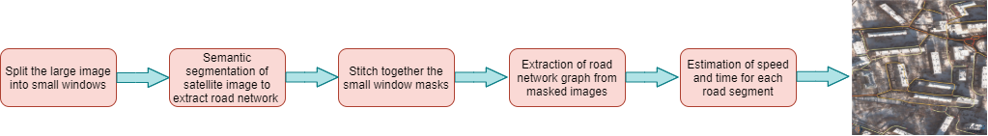
Figure 1 Flow diagram depicting the steps in the extraction of the road network, speed, and time of travel using CRESI
In the following sections, each step is explained in detail.

Split large test image into smaller windows
Satellite images tend to be larger. However, the CRESI algorithm does not work on large images due to memory saturation issues even while using GPUs. The automatic road extraction process is memory intensive, and hence images of sizes larger than 2000 X 2000 pixels cant be handled on a typical GPU. So large image needs to be split into small segments and processed, and then stitched back.

Semantic segmentation of Satellite images
Each road segment in the small window needs to be extracted along with the speed limit. A convolutional neural network-based architecture can achieve it. The process of extracting road networks, known as semantic segmentation in computer vision terminology, is achieved by a network architecture known as U-net [2]. CREST uses an architecture consisting of ResNet 34 [3] encoder and U-Net inspired decoder to segment roads and their speeds.

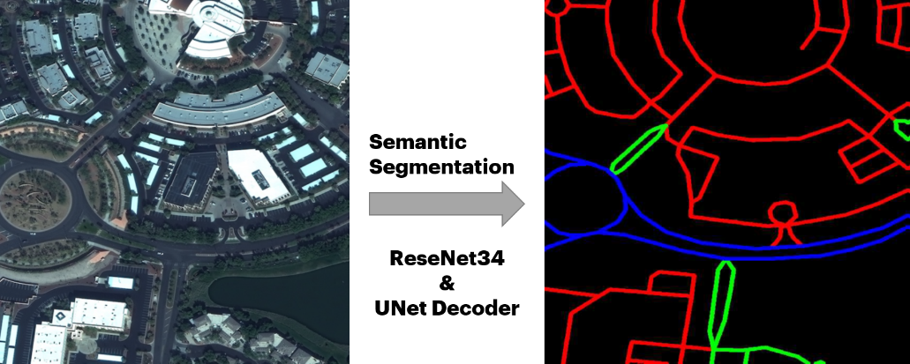
Figure 2 UNet takes a satellite image as the input and outputs a semantically segmented road network.

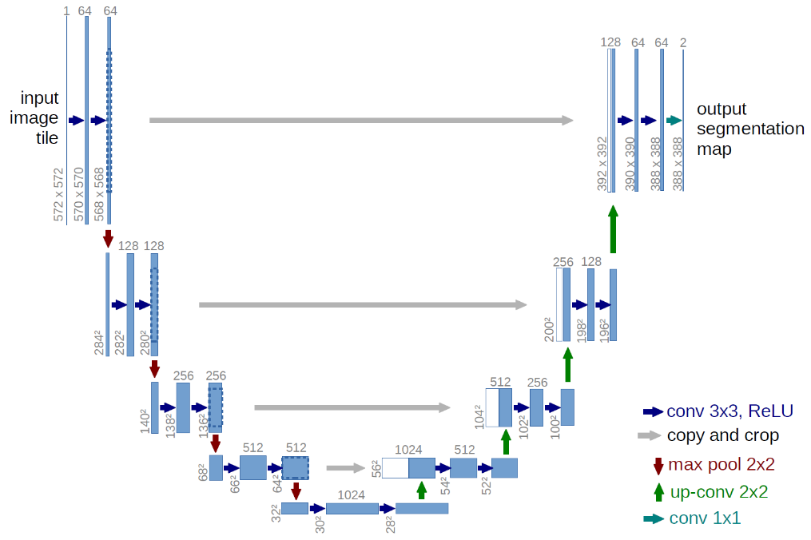
Figure 3 A Typical U-Net architecture, consisting of encoder and decoder parts, for semantic segmentation
Graph extraction
To extract road networks from masks applied by semantic segmentation requires post-processing. The masks are refined using opening and closing techniques with Gaussian kernels and removing small object artifacts and holes. Then, the refined mask is converted to a Skelton graph by using scikit-skeltonize [4]. The skeleton is converted into a graph by sknw package [5]. Any artifacts that are not removed during mask refining stage are refined further by removing disconnected subgraphs and terminal vertices. This will result in a road network graph structure.

Figure 4 Conversion of the semantic map to road-network graph through post-processing

Speed and time estimation
The U-net usually will not classify all pixels in a road segment into the same class as there will be misclassifications. Hence, each predicted road segment will have pixels from all speed limits. So, to estimate the speed limit for a given road segment, the middle of the segment is considered, and the average speed of the pixels in that patch is considered as the speed of the road segment. Using the speed and length of the road segment, time of travel can be easily calculated.

Figure 5 Estimation of speed and time of travel
References
- Van Etten, Adam. "City-scale road extraction from satellite imagery v2: Road speeds and travel times." 2020 IEEE Winter Conference on Applications of Computer Vision (WACV). IEEE, 2020.
- Ronneberger, Olaf, Philipp Fischer, and Thomas Brox. "U-Net: Convolutional networks for biomedical image segmentation. arXiv 2015." arXiv preprint arXiv:1505.04597 (2019).
- He, Kaiming, et al. "Deep residual learning for image recognition." Proceedings of the IEEE conference on computer vision and pattern recognition. 2016.
- scikit image. Skeletonize. https://scikit-image.org/docs/dev/auto_examples/edges/plot_skeleton.html, 2018.
- yxdragon. Skeleton network. https://github.com/yxdragon/sknw, 2018.

